SESHADRI RAO GUDLAVALLERU

ENGINEERING COLLEGE



Machine Learning Based Music Genre Classification on Spotify Data Using IBM Watson

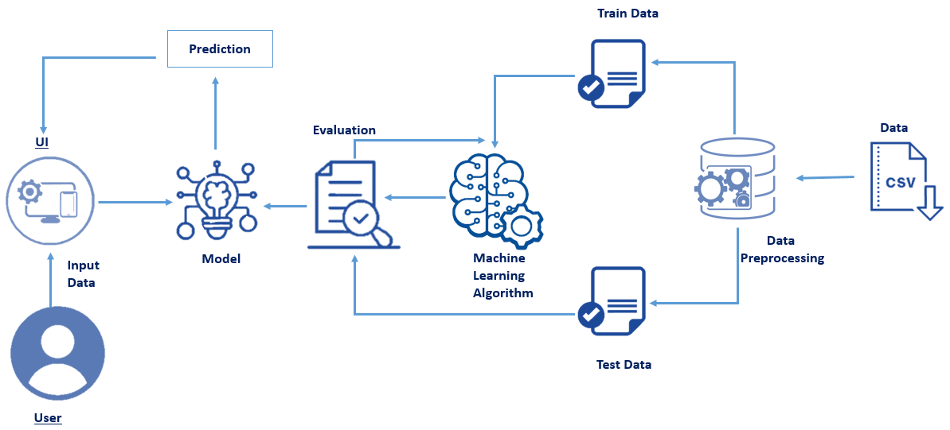

**SUBMITTED BY:**

NAME : K.SAIKUMAR

PIN : 20485A0311

**Content**

**1 INTRODUCTION**

1.1 Abstract

The use of this project. What can be achieved using this.

1.2 Overview

A brief description about your project

**2 LITERATURE SURVEY**

2.1 Existing problem

Existing approaches or method to solve this problem

2.2 Proposed solution

What is the method or solution suggested by you?

**3 THEORITICAL ANALYSIS**

3.1 Block diagram

Diagrammatic overview of the project.

3.2 Hardware / Software requirements

Hardware and software requirements of the project

**4 EXPERIMENTAL INVESTIGATIONS**

Analysis or the investigation made while working on the solution

**5 FLOWCHART**

Diagram showing the control flow of the solution

**6 RESULT**

Final findings (Output) of the project along with screenshots.

**7 ADVANTAGES**

List of advantages of the proposed solution

**8 CONCLUSION**

Conclusion summarizing the entire work and findings.

**9 BIBILOGRAPHY**

References of previous works or websites visited analysis about the project.

**1 INTRODUCTION**

**Abstract:**

Throughout the course we mainly focused around computer vision tasks and a little bit of NLP. I decided to reach out a new field and use the meachine learning techniques I learned on the field of sound processing. This paper discuss the task of classifying the music genre of a sound sample

Music Genre Classiﬁcation using Machine Learning Techniques

Hareesh Bahuleyan

University of Waterloo, ON, Canada

hpallika@uwaterloo.ca

Abstract

Categorizing music ﬁles according to their

genre is a challenging task in the area

of music information retrieval (MIR). In

this study, we compare the performance

of two classes of models. The ﬁrst is a

deep learning approach wherein a CNN

model is trained end-to-end, to predict the

genre label of an audio signal, solely us-

ing its spectrogram. The second approach

utilizes hand-crafted features, both from

the time domain and frequency domain.

We train four traditional machine learning

classiﬁers with these features and compare

their performance. The features that con-

tribute the most towards this classiﬁcation

task are identiﬁed. The experiments are

conducted on the Audio set data set and we

report an AUC value of 0.894 for an en-

semble classiﬁer which combines the two

proposed approaches

Music Genre Classiﬁcation using Machine Learning Techniques

Hareesh Bahuleyan

University of Waterloo, ON, Canada

hpallika@uwaterloo.ca

Abstract

Categorizing music ﬁles according to their

genre is a challenging task in the area

of music information retrieval (MIR). In

this study, we compare the performance

of two classes of models. The ﬁrst is a

deep learning approach wherein a CNN

model is trained end-to-end, to predict the

genre label of an audio signal, solely us-

ing its spectrogram. The second approach

utilizes hand-crafted features, both from

the time domain and frequency domain.

We train four traditional machine learning

classiﬁers with these features and compare

their performance. The features that con-

tribute the most towards this classiﬁcation

task are identiﬁed. The experiments are

conducted on the Audio set data set and we

report an AUC value of 0.894 for an en-

semble classiﬁer which combines the two

proposed approaches

**Overview:**

Music is like a mirror, and it tells people a lot about who you are and what you care about, whether you like it or not. We love to say “you are what you stream”.

Companies nowadays use music classification, either to be able to place recommendations to their customers (such as Spotify, Soundcloud) or simply as a product (for example Shazam). Determining music genres is the first step in that direction. Machine Learning techniques have proved to be quite successful in extracting trends and patterns from a large pool of data. The same principles are applied in Music Analysis also.

Music genre classiﬁcation has been a widely stud-

ied area of research since the early days of the

Internet. Tzanetakis and Cook (2002) addressed

this problem with supervised machine learning ap-

proaches such as Gaussian Mixture model and k-

nearest neighbour classiﬁers. They introduced 3

sets of features for this task categorized as tim-

bral structure, rhythmic content and pitch con-

tent. Hidden Markov Models (HMMs), which

have been extensively used for speech recognition

tasks, have also been explored for music genre

classiﬁcation (Scaringella and Zoia,2005;Soltau

et al.,1998).

Music genre classiﬁcation has been a widely stud-

ied area of research since the early days of the

Internet. Tzanetakis and Cook (2002) addressed

this problem with supervised machine learning ap-

proaches such as Gaussian Mixture model and k-

nearest neighbour classiﬁers. They introduced 3

sets of features for this task categorized as tim-

bral structure, rhythmic content and pitch con-

tent. Hidden Markov Models (HMMs), which

have been extensively used for speech recognition

tasks, have also been explored for music genre

classiﬁcation (Scaringella and Zoia,2005;Soltau

et al.,1998).

Music genre classiﬁcation has been a widely stud-

ied area of research since the early days of the

Internet. Tzanetakis and Cook (2002) addressed

this problem with supervised machine learning ap-

proaches such as Gaussian Mixture model and k-

nearest neighbour classiﬁers. They introduced 3

sets of features for this task categorized as tim-

bral structure, rhythmic content and pitch con-

tent. Hidden Markov Models (HMMs), which

have been extensively used for speech recognition

tasks, have also been explored for music genre

classiﬁcation (Scaringella and Zoia,2005;Soltau

et al.,1998). **2 LITERATURE SURVEY**

**2.1 Existing problem**

You’ll be able to understand the problem to classify if it is a regression or a classification kind of problem.

You will be able to know how to pre-process/clean the data using different data preprocessing techniques.

     You will able to analyse or get insights into data through visualization.

    Applying different algorithms according to the dataset and based on visualization.

You will able to know how to find the accuracy of the model.

 You will be able to know how to build a web application using the Flask framework.

**2.2 Proposed solution**

By doing this project we classify if it is a regression or a classification kind of problem.And also able to analysis or get insights into data the In this project we are using the different algorithms according to the dataset and based on visualization

**3 THEORITICAL ANALYSIS**

**3.1 Block diagram**

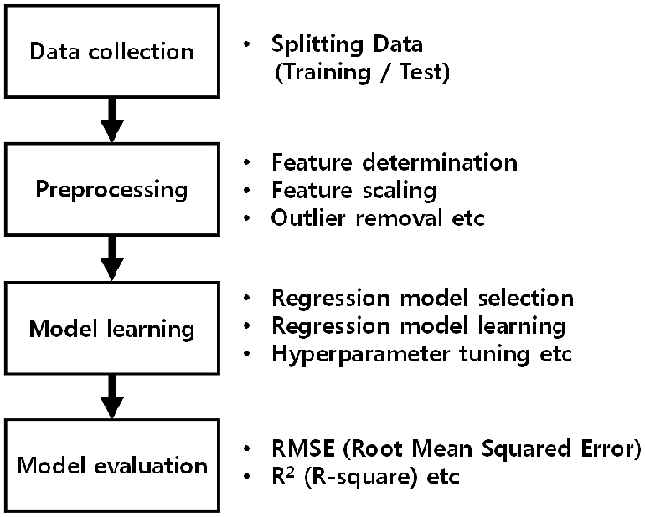

**3.2 Hardware / Software Requirements**

**Recommended System Requirements**

Processors:Intel® Core™ i5 processor 4300M at 2.60 GHz or 2.59 GHz (1 socket, 2 cores, 2 threads per core), 8 GB of DRAMIntel® Xeon® processor E5-2698 v3 at 2.30 GHz (2 sockets, 16 cores each, 1 thread per core), 64 GB of DRAMIntel® Xeon Phi™ processor 7210 at 1.30 GHz (1 socket, 64 cores, 4 threads per core), 32 GB of DRAM, 16 GB of MCDRAM (flat mode enabled)

* Disk space: 2 to 3 GB
* Operating systems: Windows® 10, macOS*, and Linux*

**Minimum System Requirements**

* Processors: Intel Atom® processor or Intel® Core™ i3 processor
* Disk space: 1 GB
* Operating systems: Windows* 7 or later, macOS, and Linux
* Python* versions: 3.9

**Software requirements:**

**anaconda navigator:**

Anaconda is an open-source distribution for python and R. It is

used for data science, machine learning, deep learning, etc. With the availability of more than 300 libraries for data science, it becomes fairly optimal for any programmer to work on anaconda for data science.

**Pycharm:**

PyCharm is a dedicated Python Integrated Development Environment (IDE) providing a wide range of essential tools for Python developers, tightly integrated to create a convenient environment for productive Python, web, and data science development.

**4 EXPERIMENTAL INVESTIGATIONS**

**BAGGING CLASSFIER :**

Bagging, also known as Bootstrap aggregating, is **an ensemble learning technique that helps to improve the performance and accuracy of machine learning algorithms**. It is used to deal with bias-variance trade-offs and reduces the variance of a prediction model.

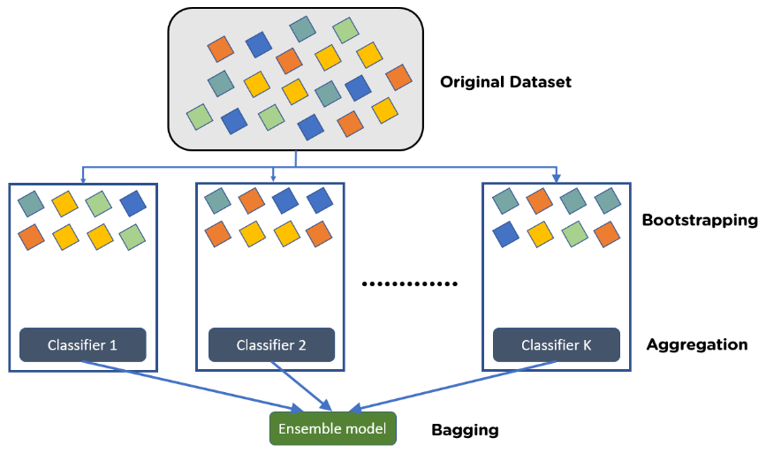

* Consider there are n observations and m features in the training set. You need to select a random sample from the training dataset without replacement
* A subset of m features is chosen randomly to create a model using sample observations
* The feature offering the best split out of the lot is used to split the nodes
* The tree is grown, so you have the best root nodes

**5 FLOW CHART**

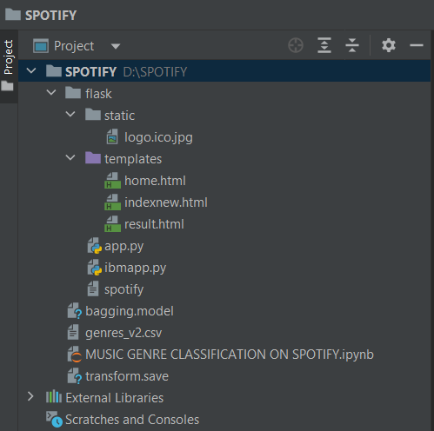

**6 RESULT**

For Getting Music Genre prediction for spotify We will Enter Our Results

Of All The Fields Enter Here And Check The Probability :

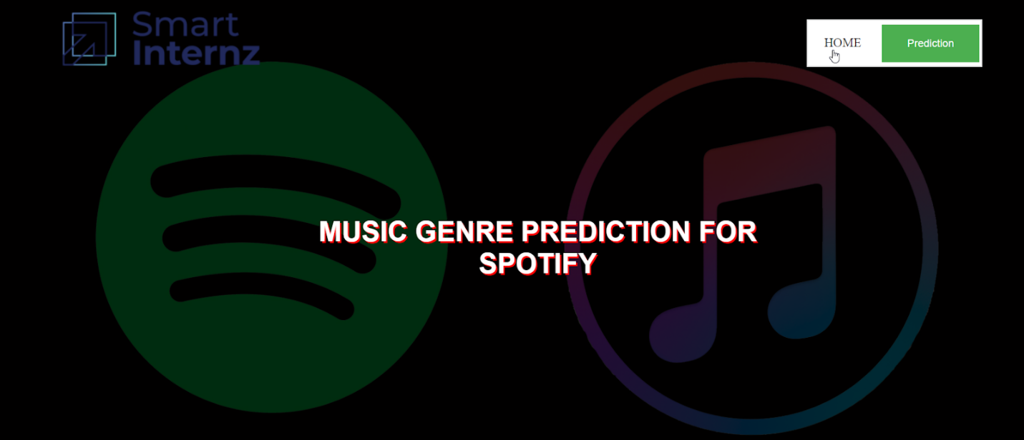

If u click on the Home button it will refresh the home page

If u click on the prediction button it will redirect to new web page

Enter input Of All The Fields Enter Here And Check The Probability

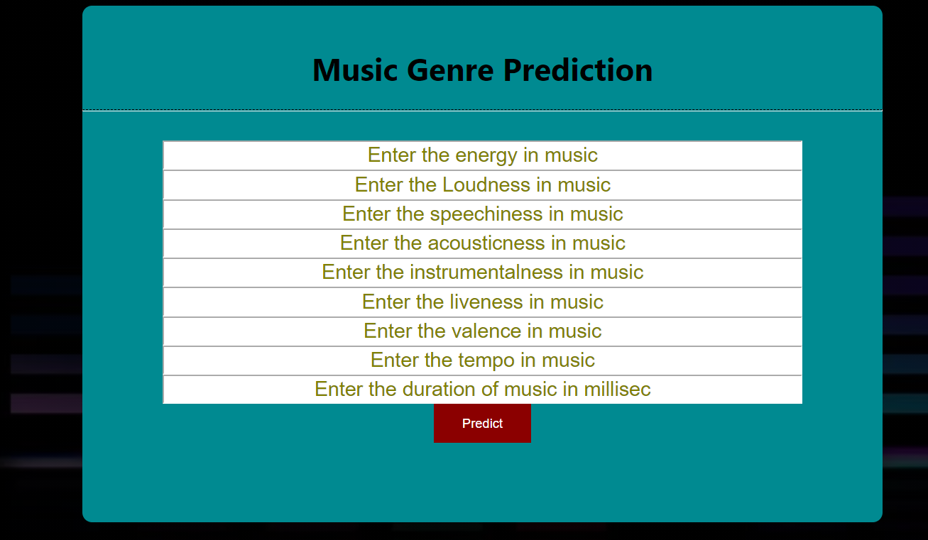 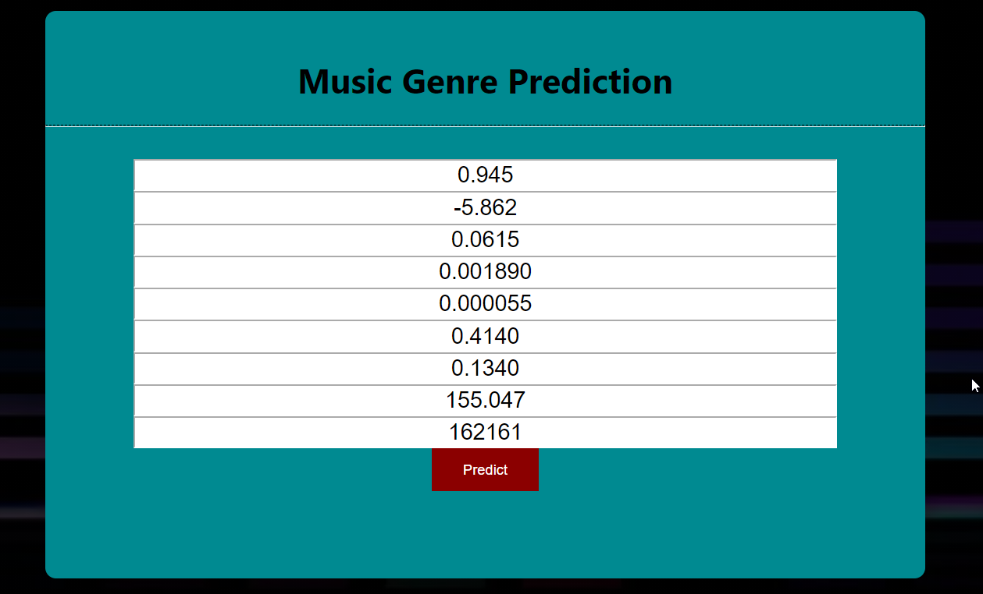



**7 ADVANTAGES OF A PROJECT**

**ADVANTAGES :**

1. The main thing to identify and divide the audio into different features is amplitude and frequency that changes within a short span of time.
2. We can visualize the audio frequency wave of amplitude and frequency with respect to time in form of a wave plot that can be easily plotted using librosa.
3. MFCCs total provides 39 features related to frequency and amplitude. In that 12 parameters are related to the amplitude of frequencies. It means it provides us with enough frequency channels to analyze audio and this is the reason MFCCs are used everywhere for feature extraction in audios.
4. The key working of MFCC is to remove vocal excitation (pitch information) by dividing audio into frames, make extracted features independent, adjust the loudness, and frequency of sound according to humans, and capture the context.

**8 CONCLUSION**

Automatic genre classification is a difficult and problematic task that none

the less has important value in terms of both pure research and commercial application. Continuing research in automatic genre classification has much to of-

fer, as does parallel research involving other aspects of musical similarity.

Automatic genre classification performance appears to have fallen into a local maximum recently, and serious modifications to the approaches used are needed in order to realize further improvements.

• Information from low-level, high-level and cultural features

• Information from low-level, high-level and cultural features

Information from low-level, high-level and cultural features

**10 BIBILOGRAPHY**

**Installation of Anaconda Navigator:**

[**https://www.youtube.com/embed/5mDYijMfSzs**](https://www.youtube.com/embed/5mDYijMfSzs)

**Installation Of Pycharm Professionals:**

[**https://www.youtube.com/embed/z73PyNDgVyQ**](https://www.youtube.com/embed/z73PyNDgVyQ)

**Installation Of Python Packages:**

[**https://www.youtube.com/embed/akj3_wTploU**](https://www.youtube.com/embed/akj3_wTploU)

**Data Collection:**

**[https://www.kaggle.com/datasets/lucascantu/spotify-dataset- albums/download?datasetVersionNumber=1](https://www.kaggle.com/datasets/rishal005/admission-predict)**

**[Data Pre-processing](https://www.kaggle.com/datasets/rishal005/admission-predict):**

[[**https://thesmartbridge.com/documents/spsaimldocs/Datapreprocessing.pdf**](https://thesmartbridge.com/documents/spsaimldocs/Datapreprocessing.pdf)](https://thesmartbridge.com/documents/spsaimldocs/Datapreprocessing.pdf)

**Handling Null Values:**

[**https://towardsdatascience.com/7-ways-to-handle-missing-values-in-machine-learning-1a6326adf79e**](https://towardsdatascience.com/7-ways-to-handle-missing-values-in-machine-learning-1a6326adf79e)

### Data Visualization:

<https://www.youtube.com/embed/TLdXM0A7SR8>

### Splitting Dependent And Independent Columns:

<https://www.youtube.com/embed/A_V6daPQZIU>

Splitting The Data Into Train And Test:

<https://www.youtube.com/embed/xgDs0scjuuQ>

### Training And Testing The Model:

<https://www.youtube.com/embed/yIYKR4sgzI8>

### Model Evaluation:

<https://towardsdatascience.com/the-5-classification-evaluation-metrics-you-must-know-aa97784ff226>

**Flask Frame Work Reference:**

<https://www.youtube.com/embed/lj4I_CvBnt0>

**Flask Refarance To Run:**

<https://www.youtube.com/embed/UbCWoMf80PY>

**Train The Model On IBM:**

**Account Creation:**

[**https://www.youtube.com/embed/4y_zD-0Q3F8**](https://www.youtube.com/embed/4y_zD-0Q3F8)

**Train Model On IBM Watson:**

[**https://www.youtube.com/embed/TysuP3KgSzc**](https://www.youtube.com/embed/TysuP3KgSzc)

### Integrate Flask With Scoring Endpoint:

<https://www.youtube.com/embed/ST1ZYLmYw2U>